**Exercise 01**

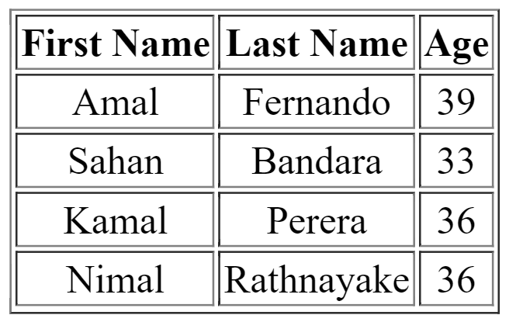Write HTML codes to create the following tables.

<html>

<head>

<title> Table 1 </title>

<style>

table {

text-align: center;

}

</style>

</head>

<body>

<table border=1>

<tr>

<th> First Name </th>

<th> Last Name </th>

<th> Age </th>

</tr>

<tr>

<td> Amal </td>

<td> Fernando </td>

<td> 39 </td>

</tr>

<tr>

<td> Sahan </td>

<td> Bandara </td>

<td> 33 </td>

</tr>

<tr>

<td> Kamal </td>

<td> Perera </td>

<td> 36 </td>

</tr>

<tr>

<td> Nimal </td>

<td> Rathnayake </td>

<td> 36 </td>

</tr>

</table>

</body>

</html>

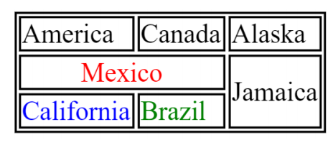**Exercise 02**

<html>

<head>

<title> Table 2 </title>

</head>

<body>

<table style="border: 2px solid black; text-align: center">

<tr>

<td style="border: 2px solid black; text-align: center"> America </td>

<td style="border: 2px solid black; text-align: center"> Canada </td>

<td style="border: 2px solid black; text-align: center"> Alaska </td>

</tr>

<tr>

<td colspan="2" style="color: #ff0000; border: 2px solid black; text-align: center"> <b> Mexico </b> </td>

<td rowspan="2" style="border: 2px solid black; text-align: center"> Jamaica </td>

</tr>

<tr>

<td style="color: #0000ff; border: 2px solid black; text-align: center"> <b> California </b> </td>

<td style="color: #1b9118; border: 2px solid black; text-align: center"> <b> Brazil </b> </td>

</tr>

</table>

</body>

</html>

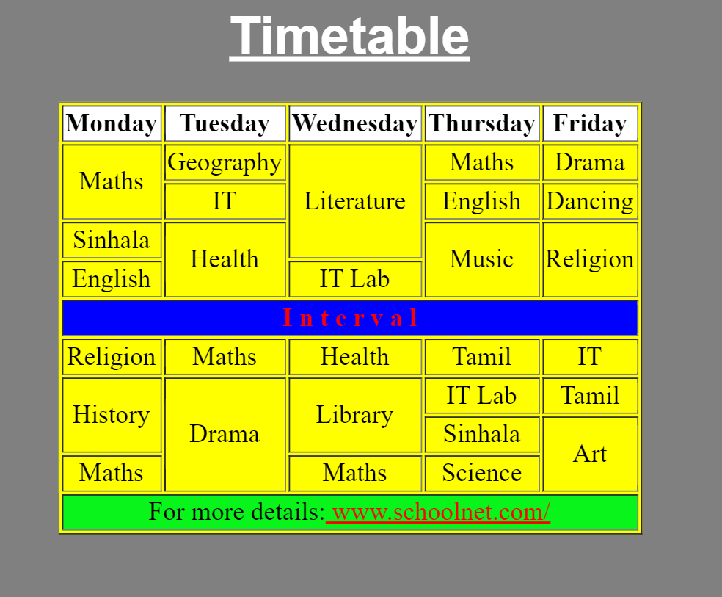**Exercise 03**

<html>

<head>

<title> Table 3 </title>

<style>

table,

th,

td {

border: 1px solid black;

text-align: center;

}

</style>

</head>

<body style="background: #8b8a8a">

<center>

<h1 style="color: #ffffff"> <u> Timetable </u> </h1>

<table style="background: #ffff00">

<tr>

<th style="background: #fff">Monday</th>

<th style="background: #fff">Tuesday</th>

<th style="background: #fff">Wednesday</th>

<th style="background: #fff">Thursday</th>

<th style="background: #fff">Friday</th>

</tr>

<tr>

<td rowspan="2">Maths</td>

<td>Geography</td>

<td rowspan="3">Literature</td>

<td>Maths</td>

<td>Drama</td>

</tr>

<tr>

<td>IT</td>

<td>English</td>

<td>Dancing</td>

</tr>

<tr>

<td>Sinhala</td>

<td rowspan="2">Health</td>

<td rowspan="2">Music</td>

<td rowspan="2">Religion</td>

</tr>

<tr>

<td>English</td>

<td>IT Lab</td>

</tr>

<tr>

<td colspan="5" style="background: #0000ff; color: #ff0000">

Interval

</td>

</tr>

<tr>

<td>religion</td>

<td>Maths</td>

<td>Health</td>

<td>Tamil</td>

<td>IT</td>

</tr>

<tr>

<td rowspan="2">History</td>

<td rowspan="3">Drama</td>

<td rowspan="2">Library</td>

<td>IT Lab</td>

<td>Tamil</td>

</tr>

<tr>

<td>Sinhala</td>

<td rowspan="2">Art</td>

</tr>

<tr>

<td>Maths</td>

<td>Maths</td>

<td>Science</td>

</tr>

<tr>

<td>religion</td>

<td>Maths</td>

<td>Health</td>

<td>Tamil</td>

<td>IT</td>

</tr>

<tr>

<td colspan="5" style="background: #32cd32"> For more details: <u style="color: red"> www.schoolnet.com/ </u> </td>

</tr>

</table>

</center>

</body>

</html>